**CATIA – Tutorial Overview**

**MCM**:

1. You can zoom in and out the Tree List or any other menu List (Ex: Options) by using CTRL + wheel.

**TUTORIAL:**

1. **Formatting**:
   1. Tools > Options > Parameters and Measure > Units
   2. Tools > Options > General > Data Save = 10 minutes
2. **Workbenches** (each workbench will have different toolsets):
   1. Start > Mechanical Design > Part Design
   2. Start > Mechanical Design > Assembly Design
   3. Start > Shape > Freestyle
3. **Customize Environment**
   1. Restore toolbars:
      * + Right Click Toolbar Area > Customize > Toolbars > Restore all contents
        + Right Click Toolbar Area > Customize > Toolbars > Restore position
   2. Customize View: Tools > Options > Display > Visualization
4. **Mouse operations** (if set up to select with left mouse button on initialization of CATIA):
   1. Zoom in / out: Hold Wheel button and press left or right mouse button.
   2. Rotate model: Hold Wheel button and left or right button and move around.
   3. Pan (move model): Hold Wheel button and move around
   4. Change center of rotation: Press wheel button to a side of the Model. This will create a new center of rotation and you will rotate from that perspective.

You can also click on a part of the model to rotate closer to the model.

* 1. Left mouse selects
  2. Right mouse opens menus

1. **Keyboard shortcuts**:
   1. Rotate model: SHIFT + arrow keys
   2. Specification tree toggle: F3
   3. Hide / Show: F9
   4. Swap visible space: F10
   5. Visual Basic: ALT + F11
   6. Start Macros: ALT + F8
   7. Swap Windows: CTRL + TAB
2. **CATIA Documents**:
   1. .CATPart
   2. .CATProduct
   3. .drawing
3. **Save Management**:
   1. Enable Independent saves
4. **Product Tree**:
   1. Specification tree toggle: F3
   2. Wheel scrolls the tree up and down
   3. Clicking on a line of the tree makes the model greyed out. This only means that the zoom in and zoom out mouse combinations will work on the tree not on the model. Or you can use ctrl + wheel to zoom the tree.
5. **Compass views (x-y-z planes on top right)**:
   1. Hide or show: View > Compass
   2. Clicking and holding the top ball of the compass allows us to rotate the model in any direction

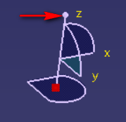

* 1. Clicking and holding any of the axes (x, y, z) allows us to move the model on that axis

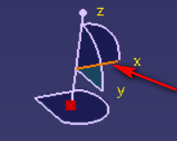

* 1. Clicking and holding any of the semicircles of the axes allows us to rotate the model around that axis.

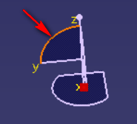

* 1. Clicking and holding a plane allows us to move the model on that plane.

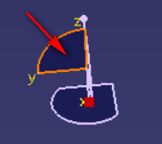

1. **Sketcher Intro**:
   1. File > New > Part > Give Name > ok
   2. Sketcher Workbench: Click the Sketcher icon as below, then click on a plane on which to create a sketch.

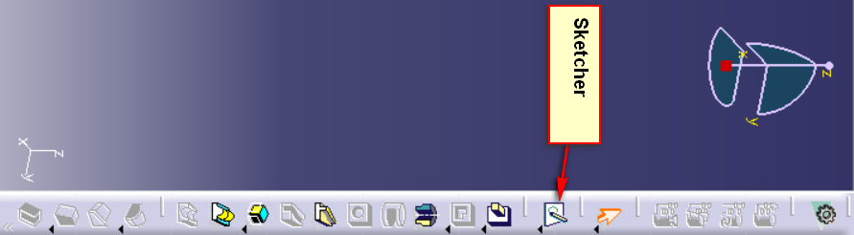

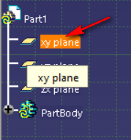

* 1. To close the Sketcher Workbench, click on Exit Workbench icon:

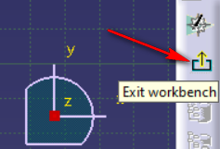

* 1. If you don’t see some toolbars, you can add them by right clicking on the right toolbar and adding the needed toolbars:

For example, Sketcher Tools:

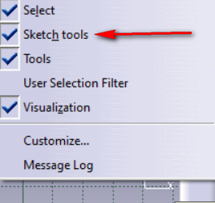

* 1. Grid toggles the grid on and off:

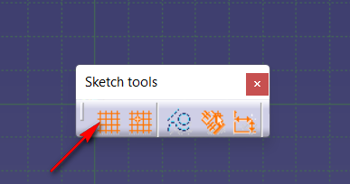

* 1. Snap to point, allows us to select only points of the grid and not in between.

Not really practical, as it is better to dimension the sketches manually and not by clicking on specific points.

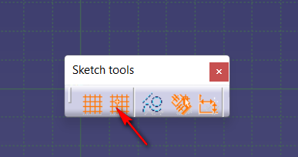

1. **Dimension Sketches:**
   1. Use the Constraints icon:

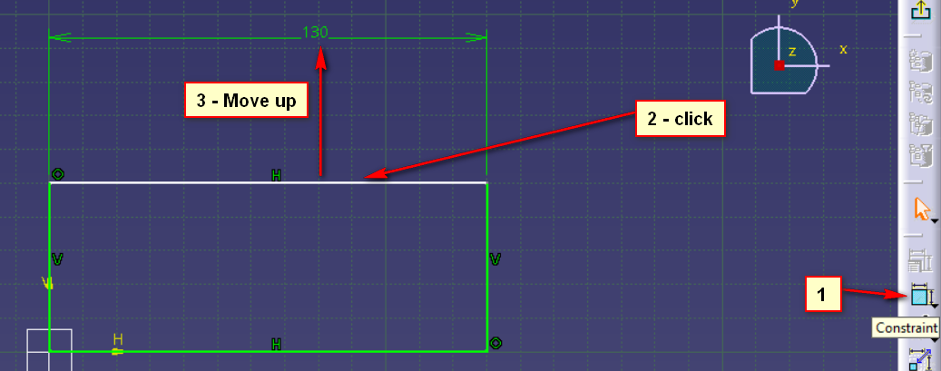

* 1. You can edit a dimension by double-clicking it and entering a new value

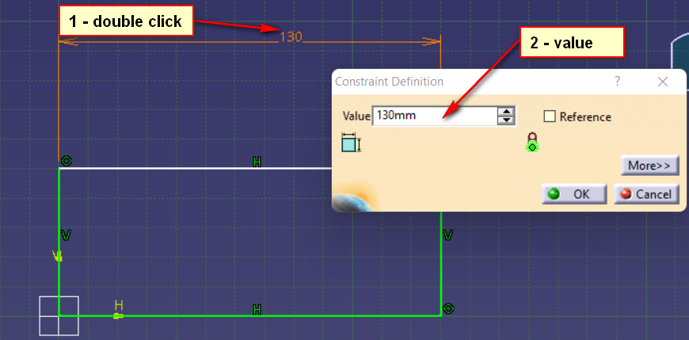

* 1. Adding multiple constraints for the same dimensions will turn the sketch purple which indicates a problem with the sketch.

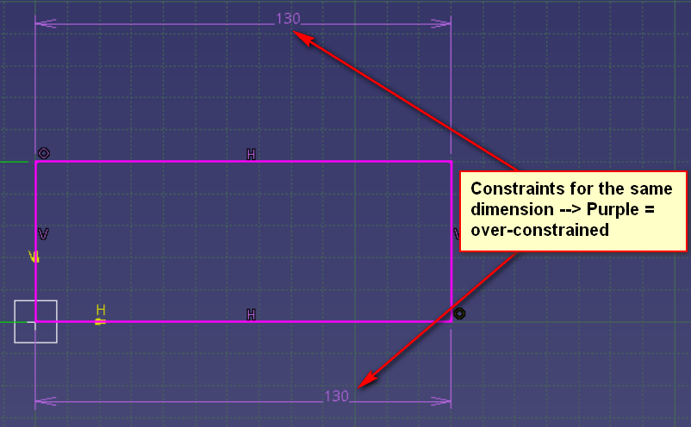

* 1. To add a dimension between two lines you click once one each line:

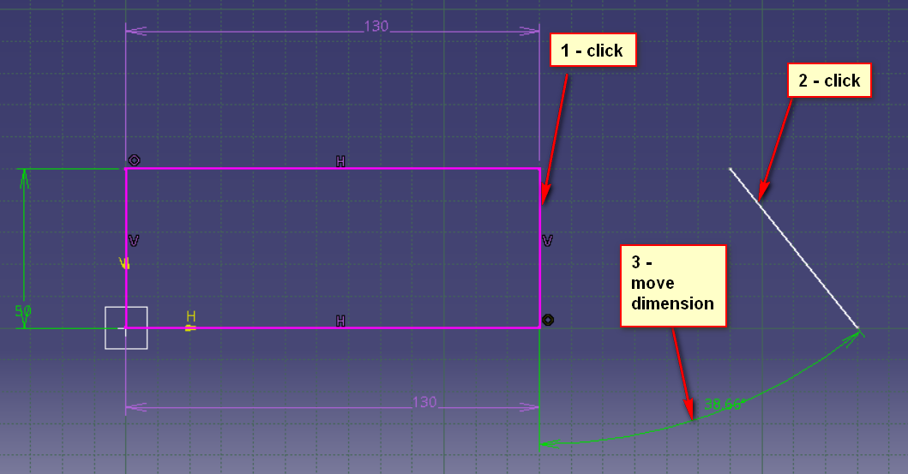

1. **Auto-constraints (auto-dimensions):**
   1. Use auto-constraints

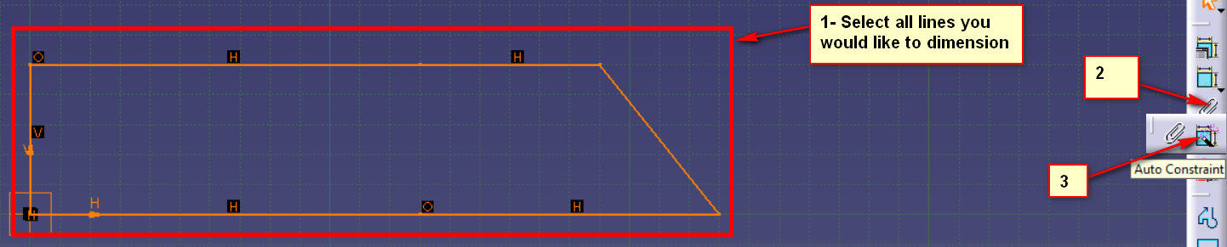

* 1. It might be easier and faster to first add all dimensions with auto-constraints and then edit them as needed, compared to having to add them one by one.

1. **Contact constraints**
   1. Contact constraints binds 2 different objects of the sketch

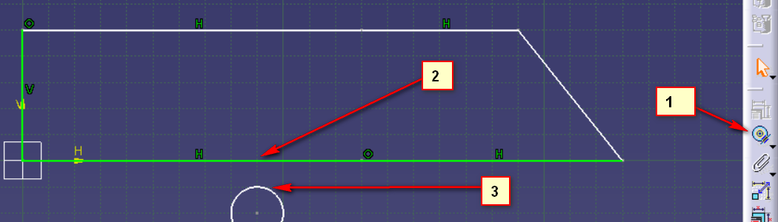

* 1. Now if you make one of them bigger or smaller they will still remain glued to one another
  2. When using contact constraints on two circles, the smaller one will go inside the bigger one. They will share the same center.

1. **Manual Sketch Edit**
   1. You can re-shape objects by clicking and holding a side and move it as needed.
   2. Circles can be moved completely by clicking and holding the center
   3. Lines can only be extended in either direction
2. **Profile Sketch**:
   1. With the profile sketch you can create a complex sketch very easy.

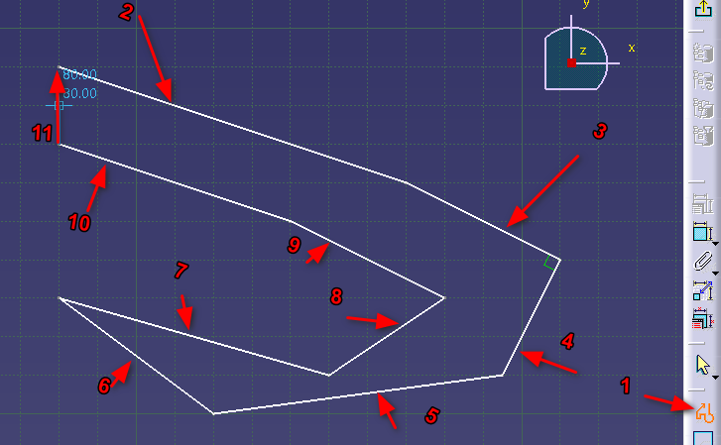

* 1. You don’t have to manually select the line tool for every line.
  2. You can also add curves, by holding and dragging the mouse until you see a rectangle as below:

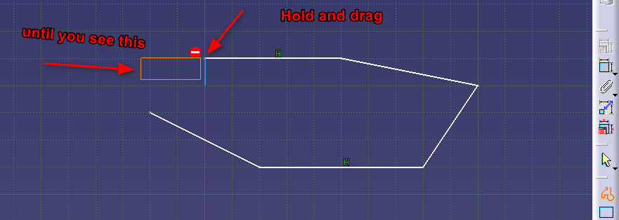

* 1. Once you release the mouse button you can add curves

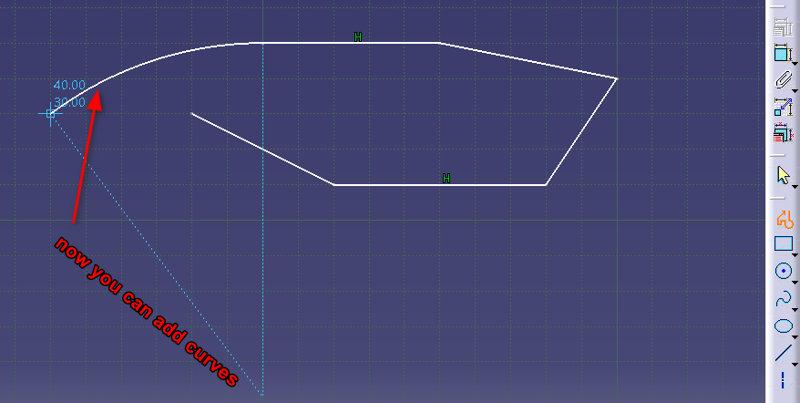

1. **Offset Sketch**:
   1. Insert > Operation > Transformation > Offset
   2. Or click on the offset icon, if available.

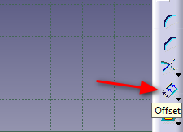

* 1. This allows us to offset either the whole sketch, or only some selected parts:

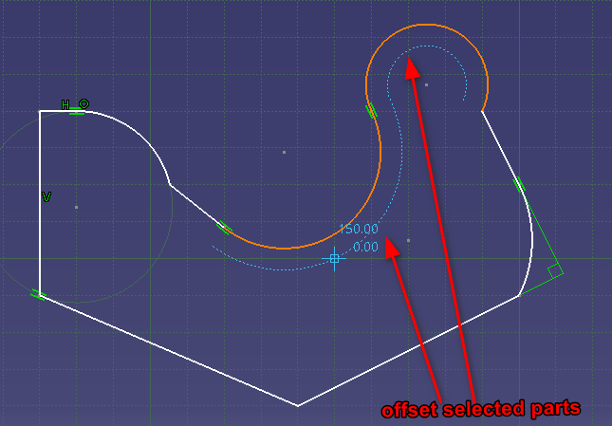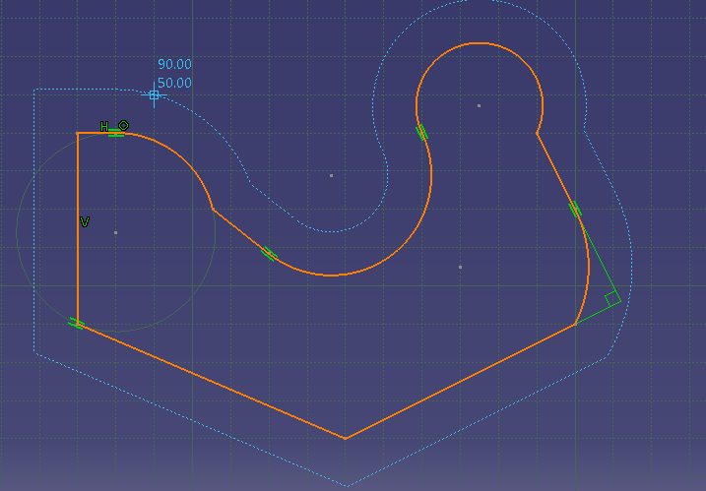

1. **Scale Sketch**:
   1. Either Insert > Operation > Transformation > Scale or use Icon:

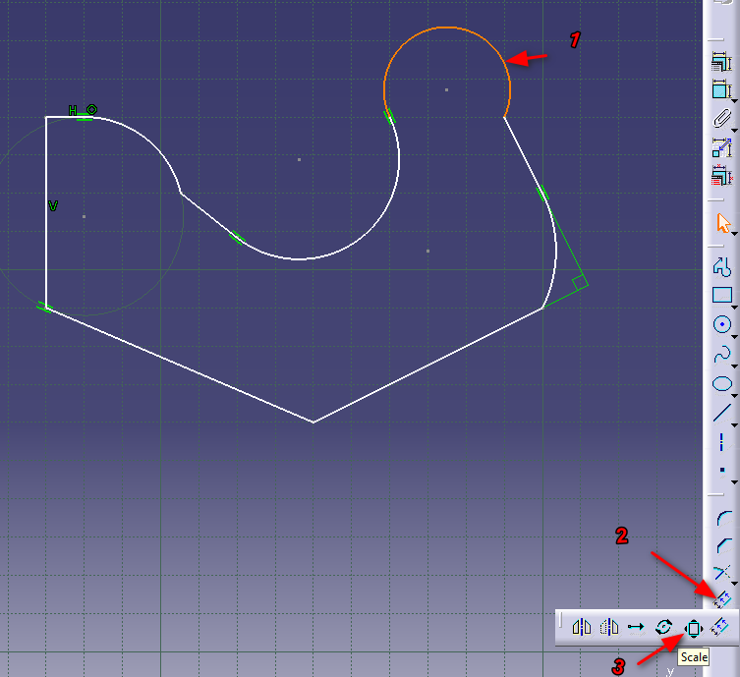

* 1. You can scale selected parts of the sketch

- Where you have the option to duplicate the selected line, or scale the selected line

- You can scale the selected part either by moving the mouse or entering a value

- You can also snap the scaled part to another point or leave it in the air

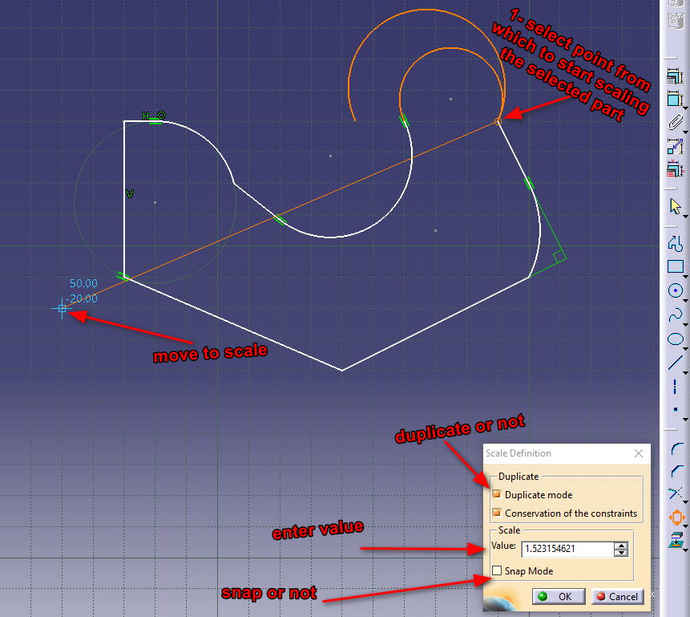

* 1. Or you can select the whole sketch and scale it.

1. **Trim / Extend Sketch**:
   1. Insert > Operation > Relimitations > Trim or icon:

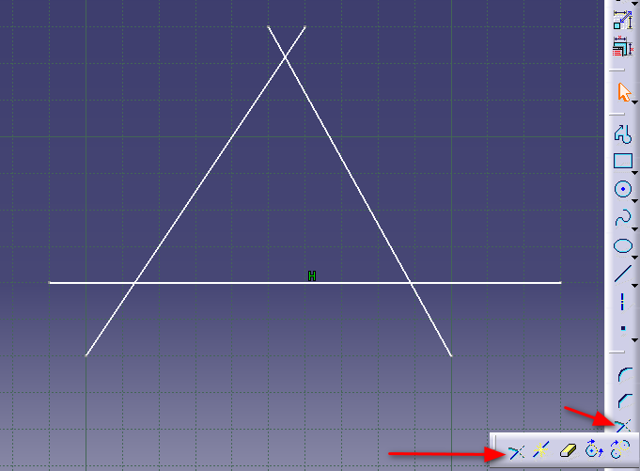

* 1. Select a line or curve you want to trim or extend.
  2. Then select another line or curve that will serve as a point to which it will trim or extend.

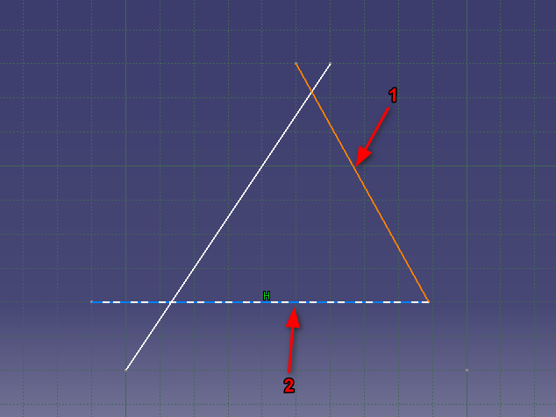

1. **Split Sketch entities (break lines)**:
   1. Split Sketch allows us to add snapping points to lines or curves
   2. Insert > Operation > Relimitations > Break or icon:

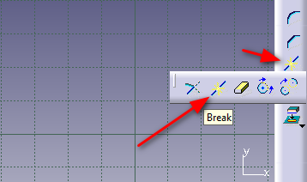

* 1. Click the line where you want to add a break point, activate Break and click where you want to add the break point:

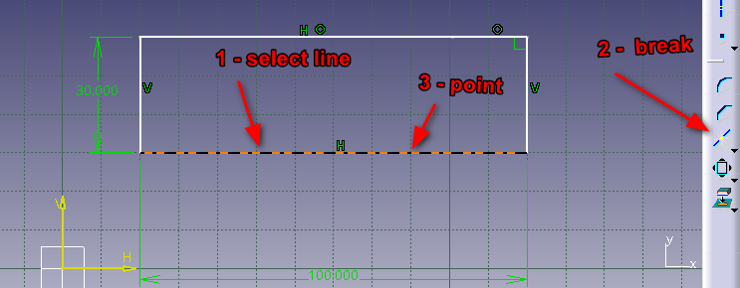

* 1. Once you have added a break point you can also dimension that point, so you can have more control of the exact position of the break:

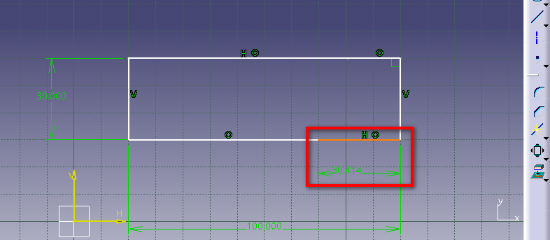

1. **Construction geometry**:
   1. Construction geometry has dotted lines and is not included in extrude or cut operations. They are only use for reference and to make dimensions.
   2. You can either select a line then select Construction Element or you can activate Construction Element, then everything you add to the sketch will be construction lines.

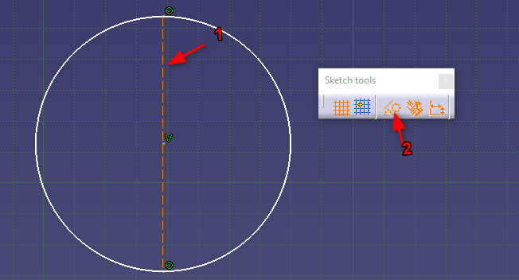

1. **Translate sketch (move sketch)**:
   1. With translate we can move or duplicate parts of a sketch to another location
   2. Insert > Operation > Transformations > Translate or icon

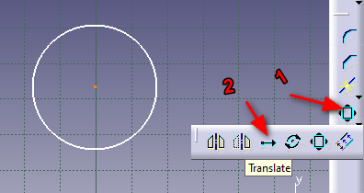

* 1. Select part to translate, activate translate.
  2. You can either duplicate it (and specify how many instances to create)
  3. Or you can translate (move) the source

1. **Rotate Sketch**:
   1. Insert > Operation > Transformations > Rotate or Icon.

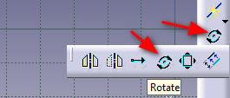

* 1. Select part to rotate, activate rotate, select a point on which to rotate, draw a line which will be used as the precision of the rotation, move sketch as needed:

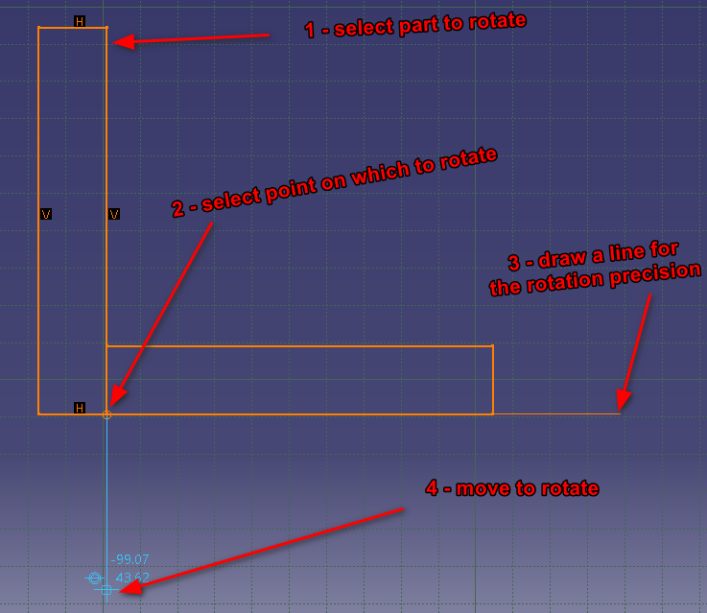

1. **Symmetry/mirror sketch**:
   1. With this feature you can easily duplicate a sketch in symmetry (mirror) over a given point or line (construction line)
   2. Draw a construction line in the direction on which you want to move or mirror your sketch.
   3. Select the sketch, activate symmetry, and select the construction line

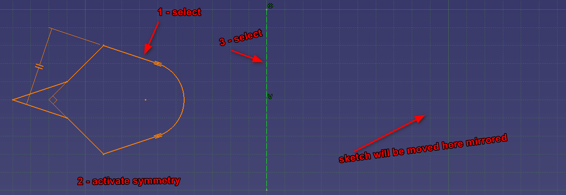

1. **Symmetry/mirror sketch**:
   1. By doing the same, but selecting mirror instead of symmetry, the sketch is duplicated instead of moved.
2. **Corner Sketch**:
   1. This can be used to make a corner round
   2. Insert > Operation > Corner or Icon:

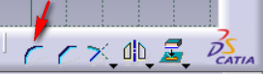

* 1. Select the 2 sides of the corner and activate Corner

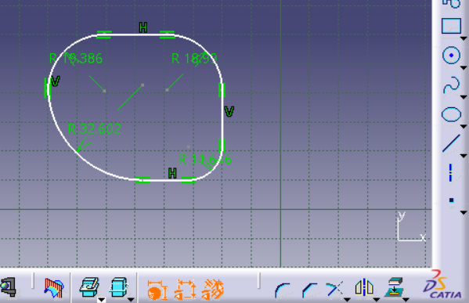

1. **Chamfer Sketch:**
   1. Similar to round corner except that is straight

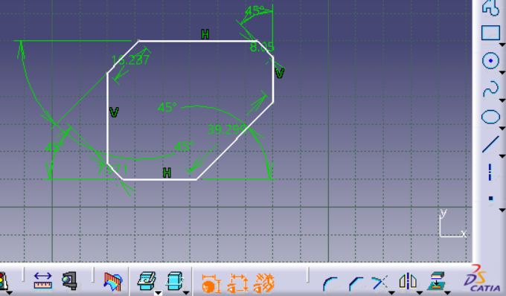

1. **Predefined profiles**:
   1. Insert > Profile > Predefined profile or from toolbar:

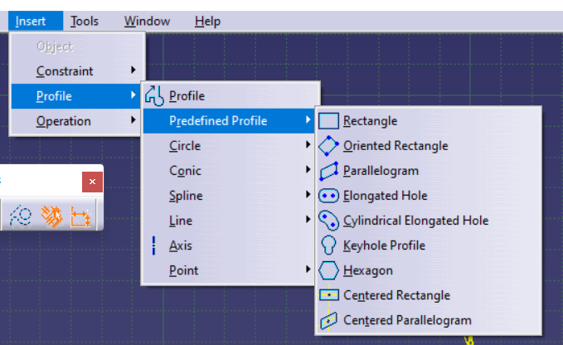

1. **Circle Profiles**:
   1. Insert > Profile > Circle or from toolbar:

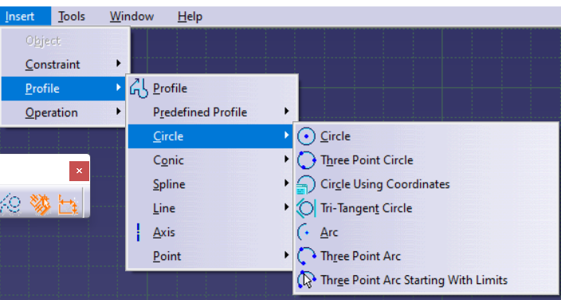

1. **Conic Profiles**:
   1. Insert > Profile > Conic or from toolbar:

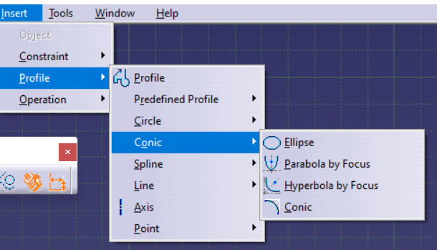

1. **Spline Definition**:
   1. A spline is a curved line between points, where each segment between two points is defined by a different function.
2. **Spline Sketch**:
   1. Insert > Profile > Spline or from toolbar:
   2. You are able to modify each segment and point
   3. You can also add dimensions and constraints to fit your needs
3. **Fix together**:
   1. You can select different parts of your sketch and then fix them together so you won’t be able to modify any of them.
   2. If you add constraints to the parts that are fixed together you will get as purple constraint (over-constrained warning)
4. **Hide / Show**:
   1. Right click part and select hide or show from the menu or from the toolbar:

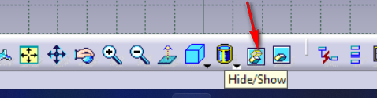

1. **Visible space**:
   1. Clicking the swap visible space will show us the space with the components that were hidden

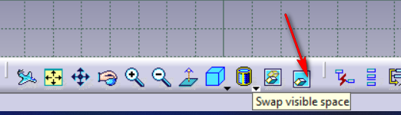

1. **Project Edges**:
   1. If you have a 3D model, you can project its edges on a specific plane
   2. This is very useful when you made a 3D model and you need to create 2D drawings for it.
   3. 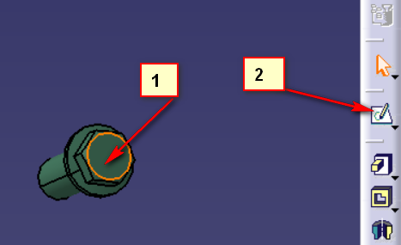Open your 3D catproduct, click on a side of it that you want to project and click open the sketcher:

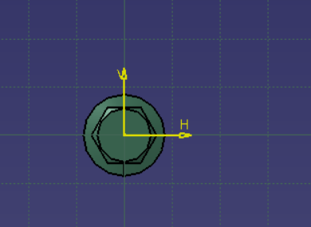

* 1. Insert > Operation > 3D Geometry > Project 3D Elements or from toolbar:

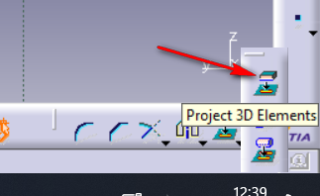

* 1. Then select the line or the part that you want to project and activate Project 3D Elements. The parts that are projected will turn yellow.

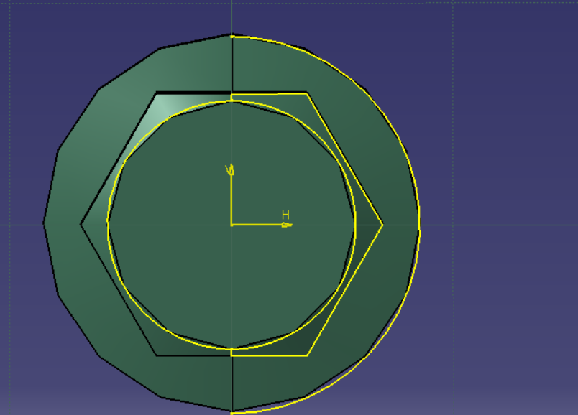

1. **Utilize Visible Space:**
   1. You can use this to hide parts and sketch over some parts and some advanced sketching.
   2. See tutorial if needed
2. **Sketch Analysis**:
   1. Will perform an analysis of the sketch and tell us if there are any issues. Ex: 2 lines are not connected in reality, etc
   2. See tutorial if needed
3. **Solid Modeling Intro**:
   1. Start > Mechanical Design > Part Design:
4. **Pad (extrude)**:
   1. Insert > Sketch-Based Features > Pad
   2. First, go into sketcher mode on any plane
   3. Draw a shape and dimension it:

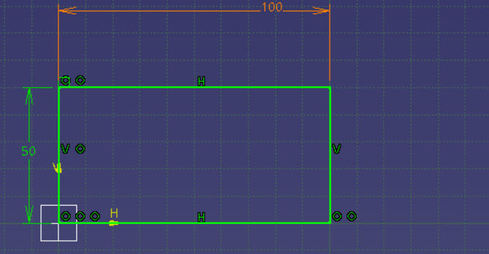

* 1. Exit sketcher and go back to part design:
  2. Next we will extrude the shape:

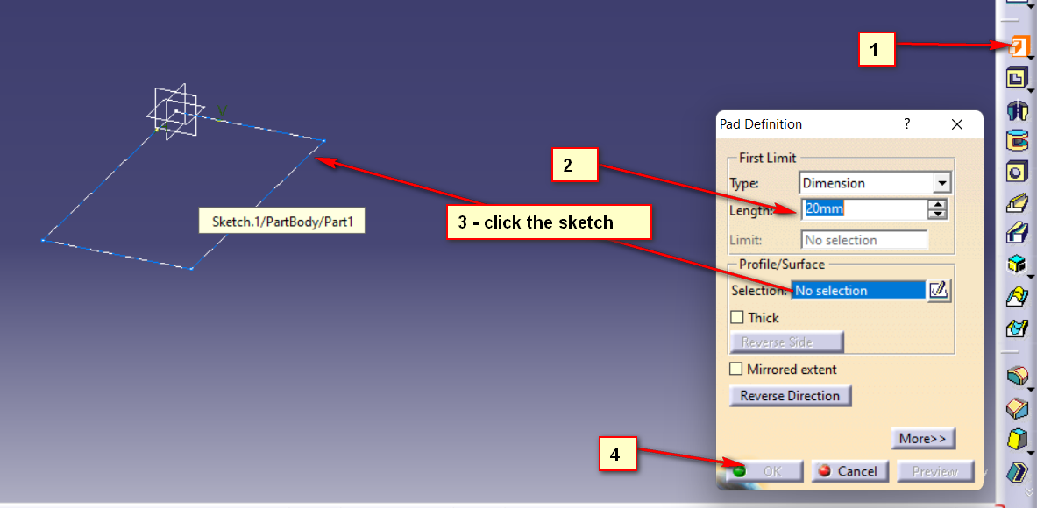

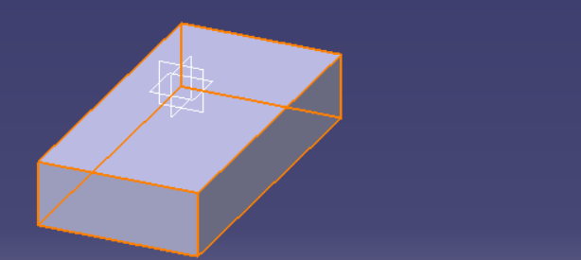

* 1. There are more options when creating pads (extruding) for more info watch the tutorial
  2. Mirrored extent will extrude in both directions (the plane on which the sketch is will be in the middle).

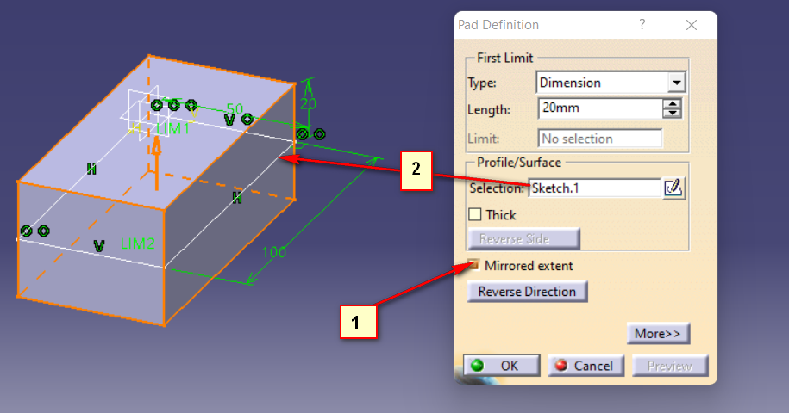

* 1. Thick will only add some thickness to the sketch and will create a hollow shape:

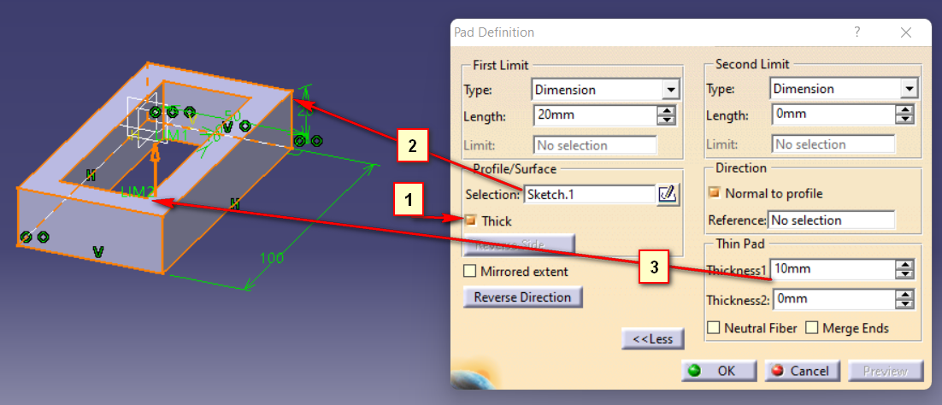

1. **Drafted Filleted Pad**:
   1. 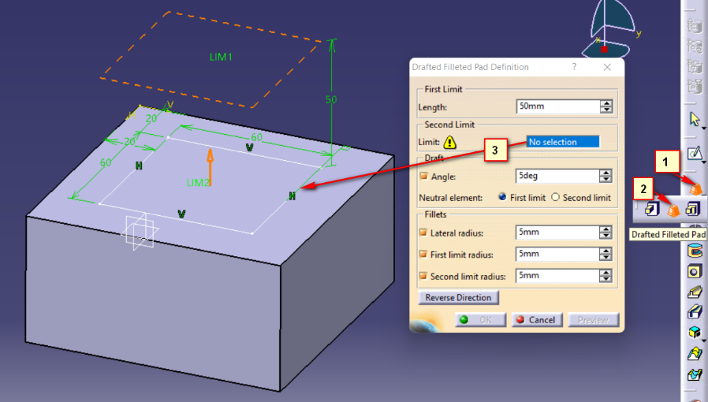See tutorial for more info:

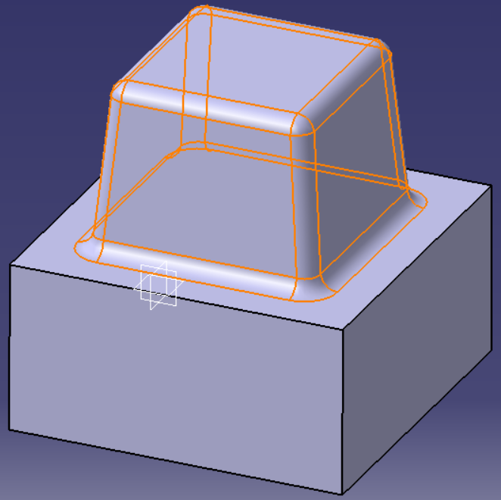

* 1. You can change the angles as needed

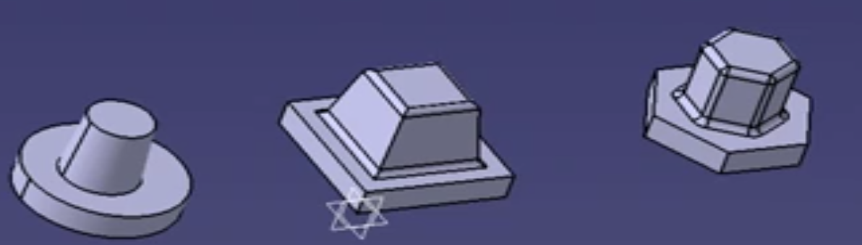

1. **Multipad**:
   1. You can extrude multiple sketches to different dimensions:

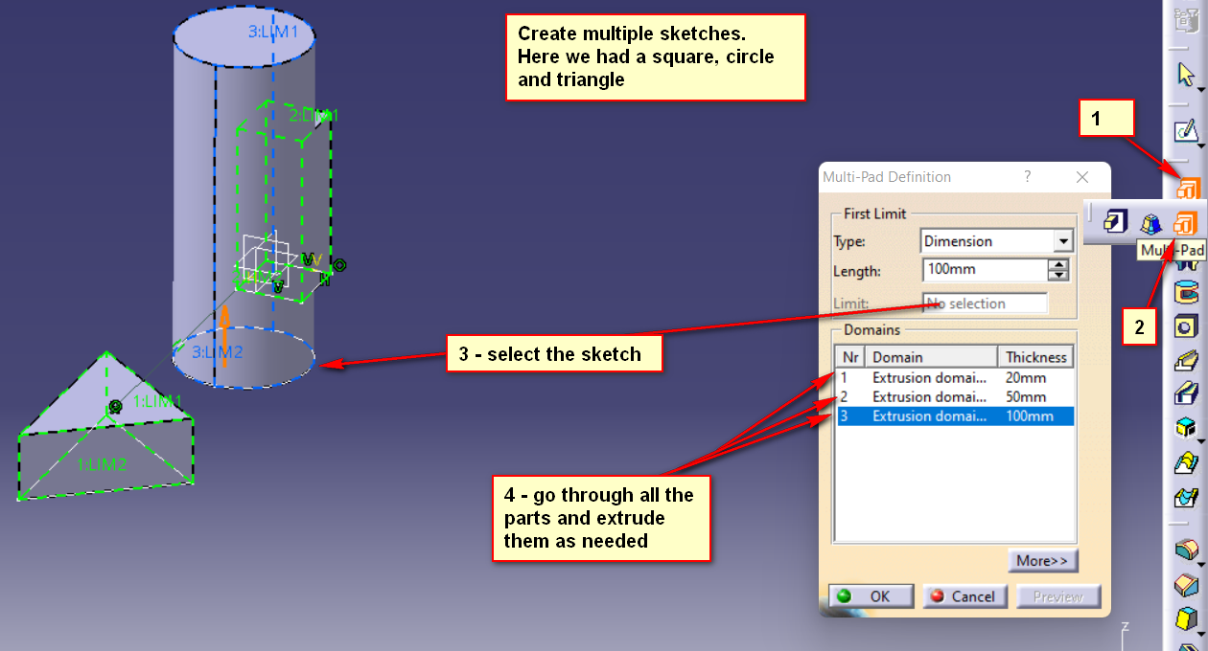

1. **Pocket**:
   1. Allows us to create holes in our solid parts

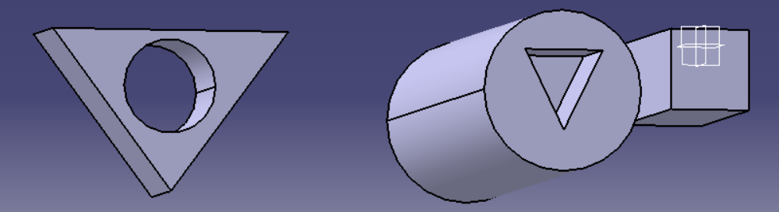

1. **Drafted Filleted Pocket**:
   1. This is similar to the Drafted Filleted pad, but as a whole. Watch tutorial if needed.

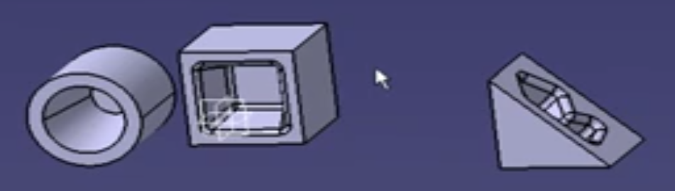

1. **Multi Pocket**:
   1. Similar to multi pad, watch tutorial if needed.
2. **Shaft**:
   1. Create shape in XY plane (for example create a star, or a circle), which will be the profile of the shaft.
   2. Dimension all, and dimension from edge of shape to XY origin

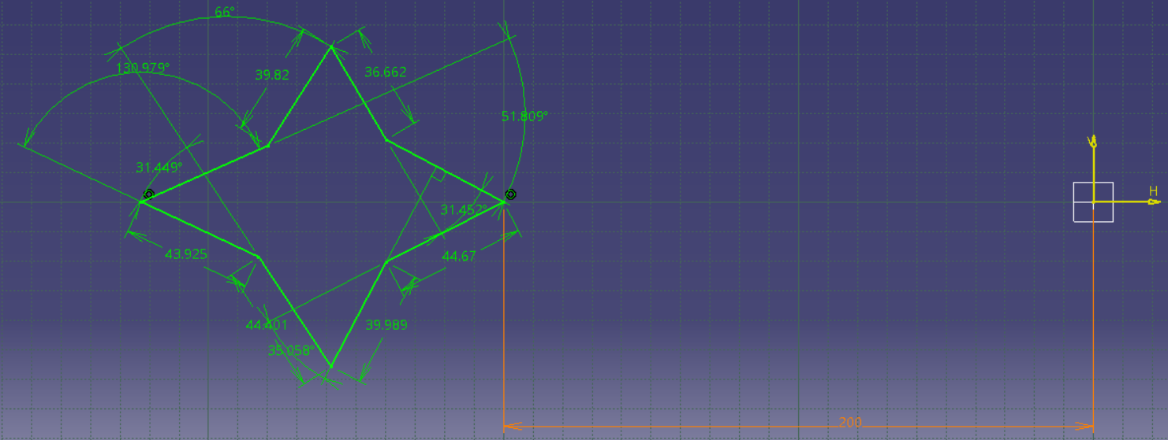

* 1. Exit sketch, select XY plane again and sketch again. This is needed to create another sketch and not use the existing one
  2. In the new sketch draw a line over the origin, which will serve as the axis for the shaft.

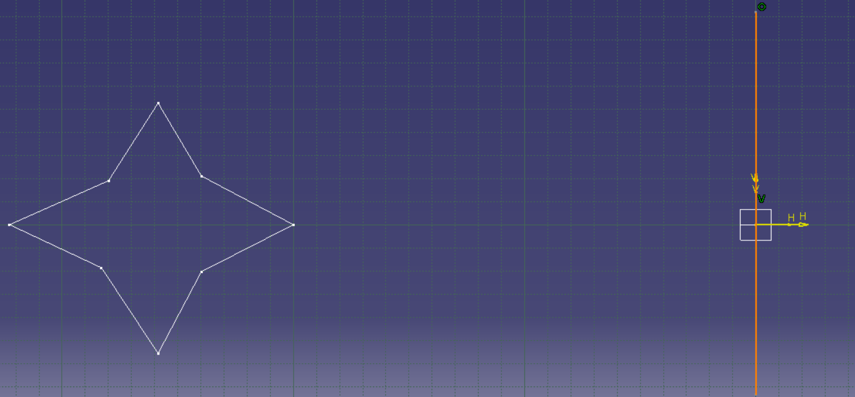

* 1. Select the profile and activate shaft. Insert > Sketch-based features > Shaft or from toolbar:

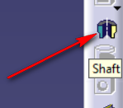

* 1. Select the profile and then the axis

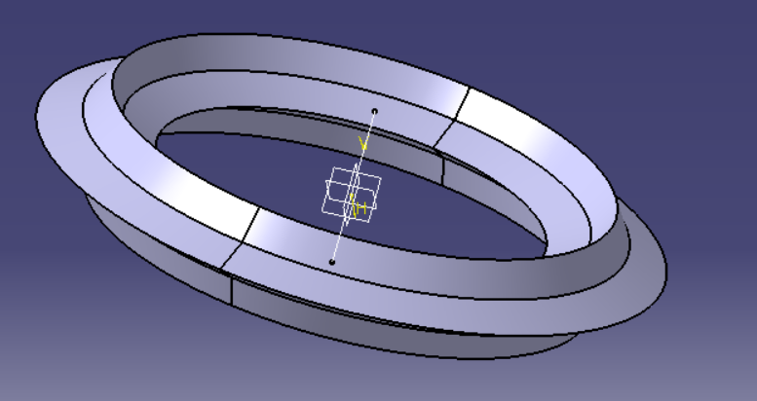

* 1. Once created you can double-click the shaft on the tree and enter the shaft definition menu, where you can edit some things

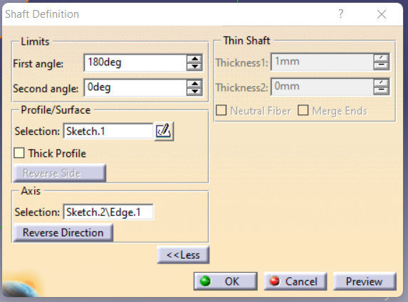

* 1. For example we can edit the First angle to input 180 degrees, this will create only a half shaft:

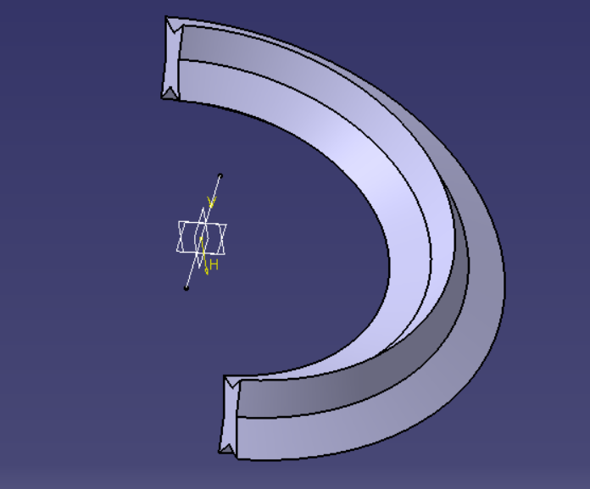

* + 1. With thickness we can create a hollow shaft:

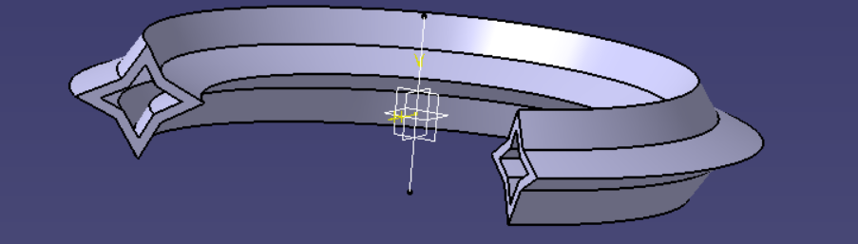

1. **Groove:**
   1. Groove is similar to shaft only that it’s creating a “hole” instead. Groove is for shaft what pocket is for pad

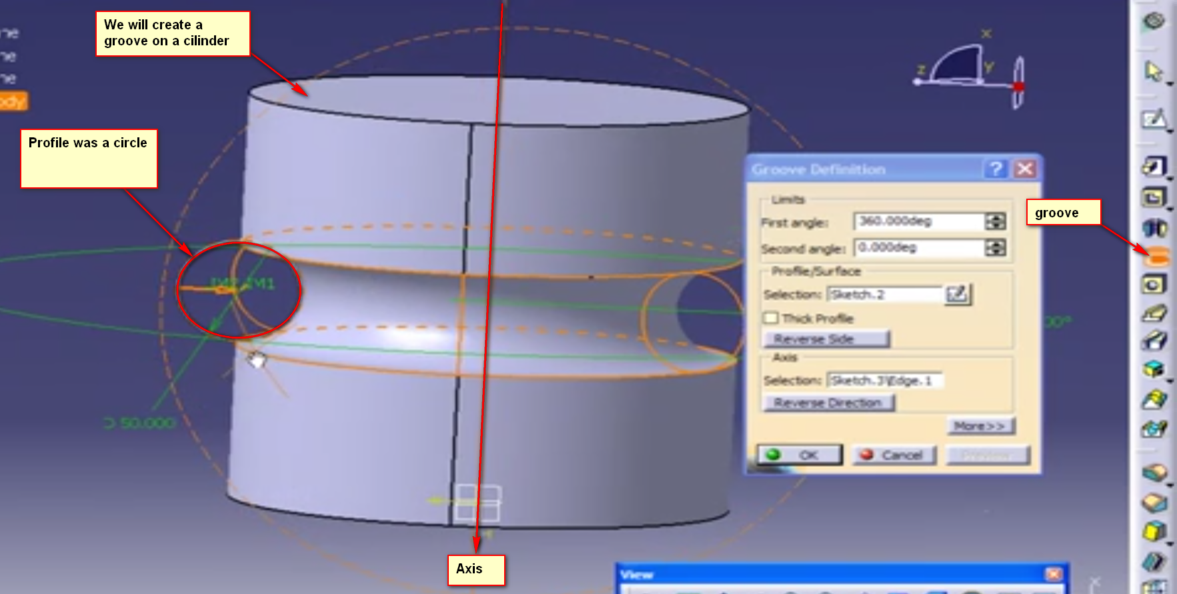

1. **Hole**:
   1. Hole is different than pocket in that it offers many predefined options for the creation of holes. Mostly I can be used to create holes for screws or similar components. You can add threads and many other options.

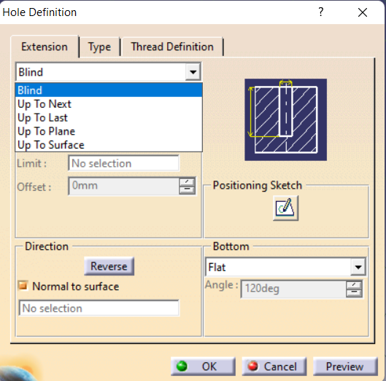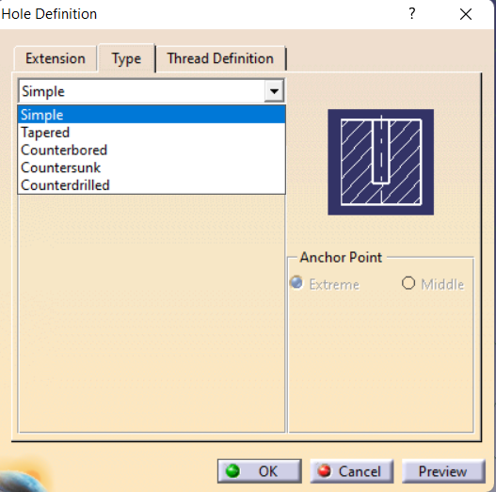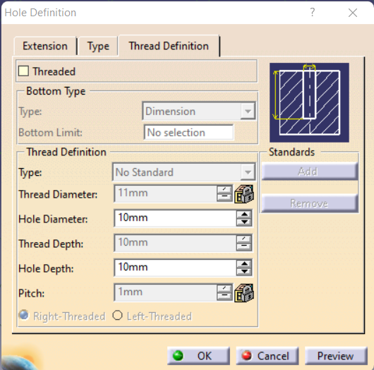

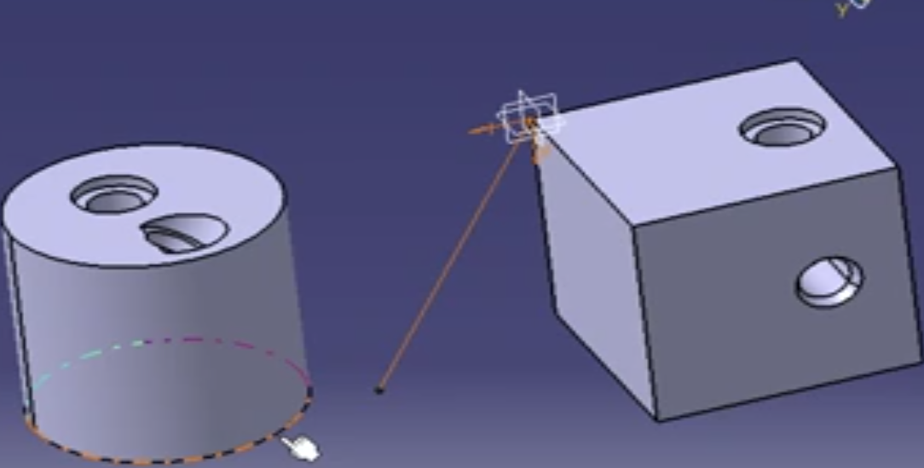

1. **Rib**:
   1. Rib is a hollow support shape that runs between two other shapes or walls:

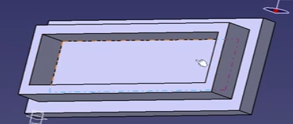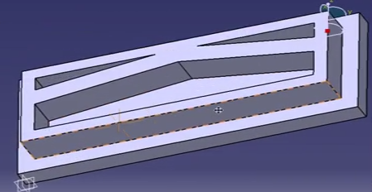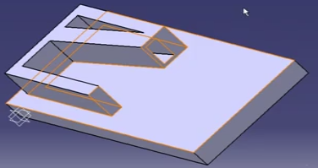

* 1. Watch tutorial for more info.

1. **Slot**:
   1. Slot is for rib what pocket is for pad.

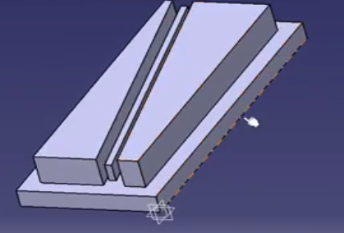 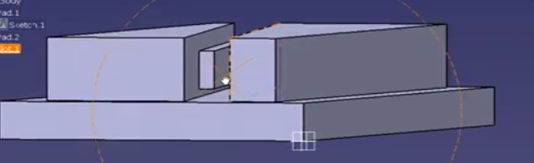

* 1. Watch tutorial for more info.

1. **Stiffener**:
   1. Can be created from a line, and can be used as a support or separator between two shapes or walls:

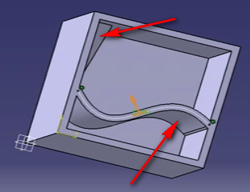

1. Watch tutorial for more info.
2. **Solid Combine**:
   1. Will give us a shape that is the result of the intersection of 2 pads.
   2. We will need to create 2 sketches on 2 planes.
   3. What solid combine will do is create a theoretical pad for both of the sketches. And where the 2 pads intersect we will see the solid combination.

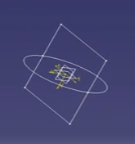 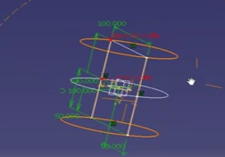 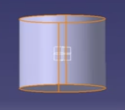

* 1. Watch tutorial for more info

1. **Reference Planes**
   1. We need to go to the Shape > Generative Shape Design.
   2. Reference planes allows us to offset existing planes or sides of a 3D model. This will allow us to create new 3D models on the same plane, but on a different distance.
   3. To create reference planes with select the plane or the side we want to offset, then select Plane Definition from the Generative Shape Design workbench.

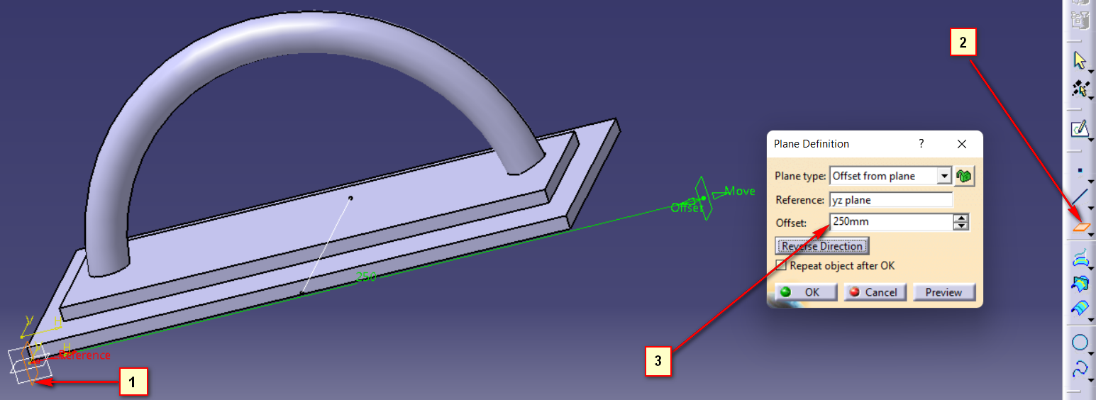

* 1. We can also create new planes by opening the Plane Definition. For example we can create a plane by selecting 3 points.

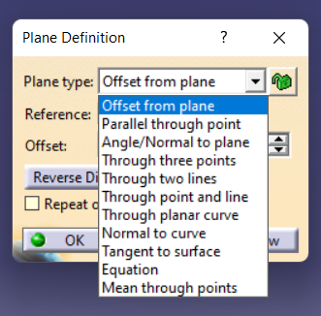

1. **Basic Multi Section Solid**:
   1. Create a reference plane from another plane and offset it by a number (Ex: 200)
   2. Create one by one, a sketch on each plane
   3. Then use the Multi Section Solid tool to create a solid between the 2 sketches.

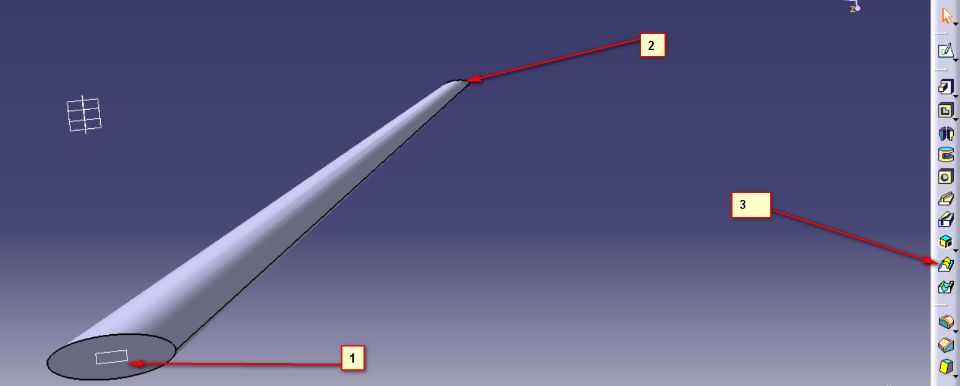

1. **Multiple Multi Section Solid**:

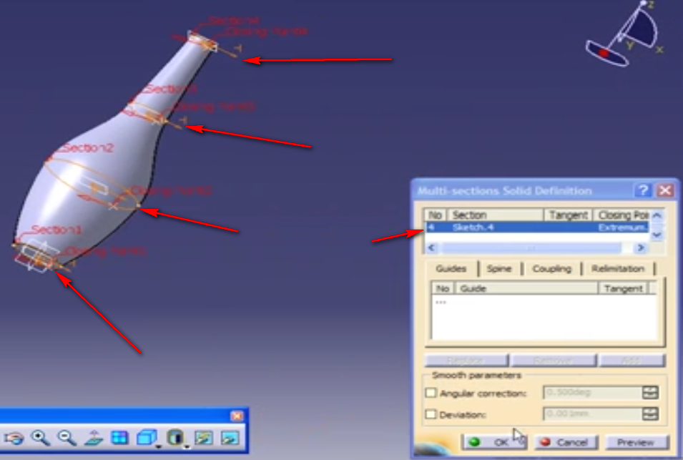

1. **Advanced Multi Section Solid**:
   1. Watch tutorial if needed
2. **Basic Removed Multi Solid**
   1. Similar to previous tool, except that it creates wholes.

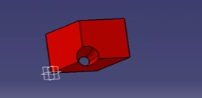

1. **Multiple** **Removed Multi Solid:**
   1. Similar to previous tool, except that it creates wholes.

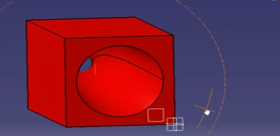

1. **Advanced Removed Multi Solid**
   1. Similar to previous tool, except that it creates wholes.
2. **Edge Fillet**:
   1. Watch tutorial if needed:

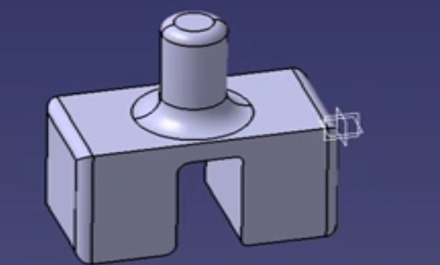

1. **Variable Radius Fillet:**
   1. Watch tutorial if needed:

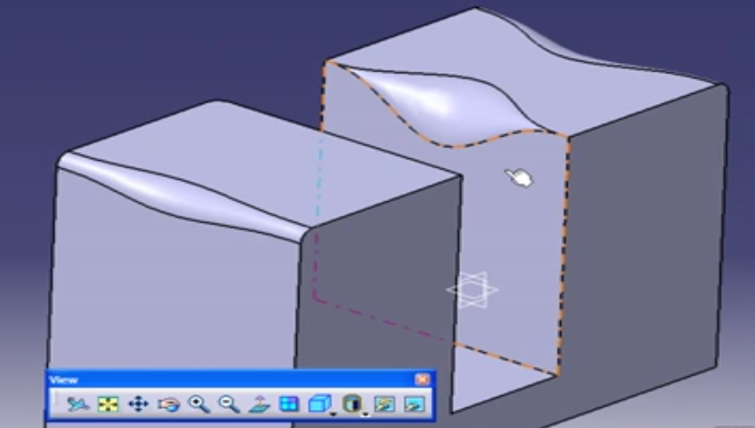

1. **Face - Face Fillet:**
   1. Watch tutorial if needed
2. **Tritangent Fillet**:
   1. Watch tutorial if needed:

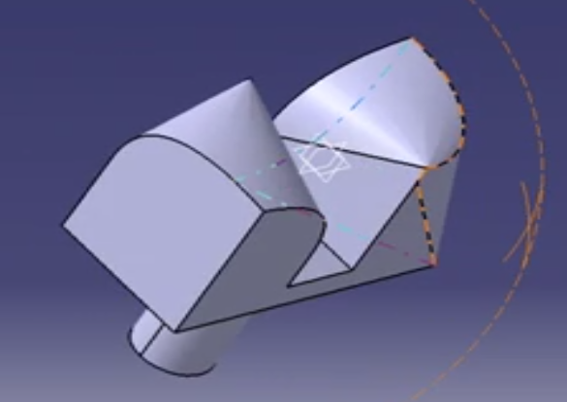

1. **Chamfer**:
   1. Watch tutorial if needed

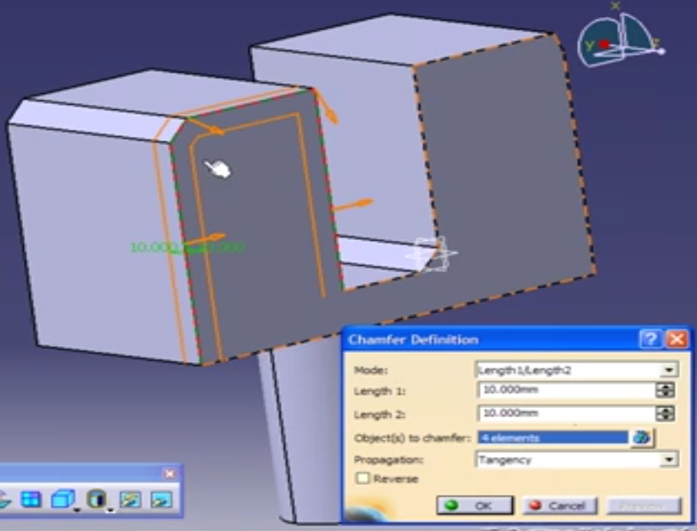

1. **Draft Angle**
   1. Watch tutorial if needed:

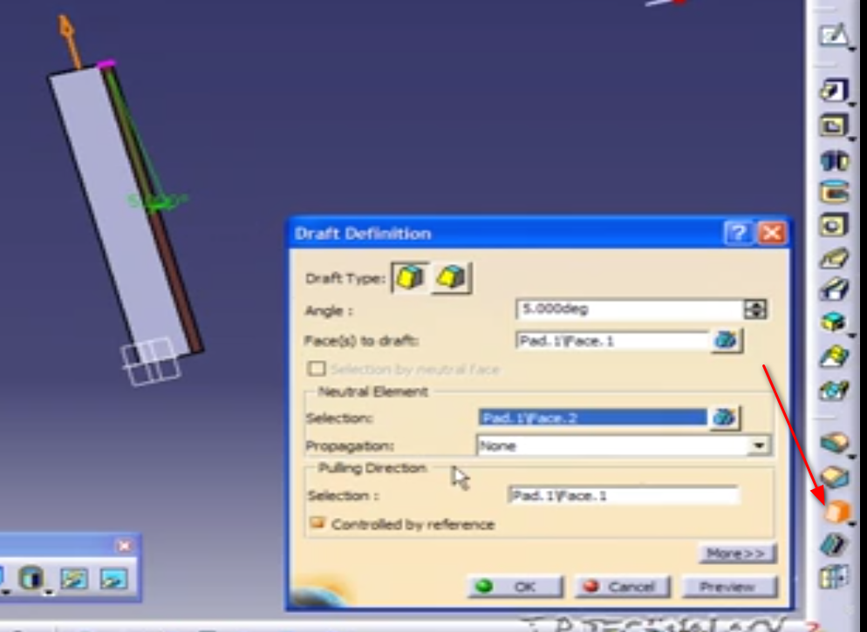 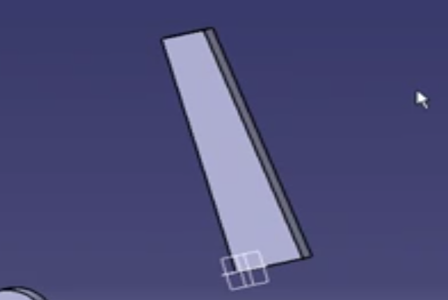

1. **Variable angle draft**:
   1. Watch the tutorial if needed:

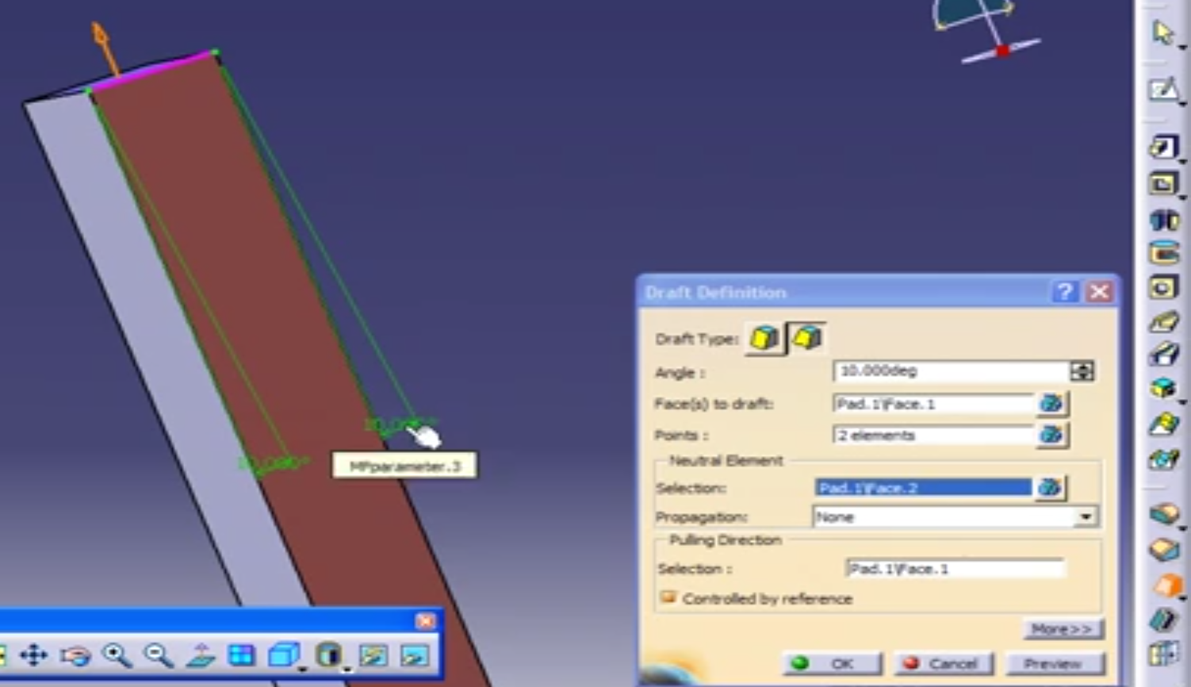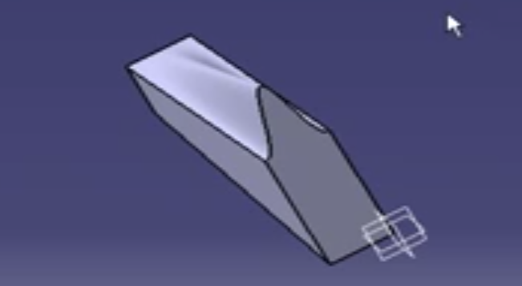

1. **Shell:**
   1. Watch tutorial if needed:

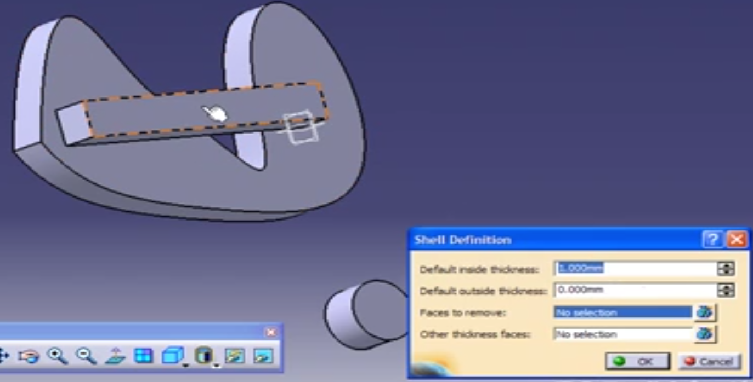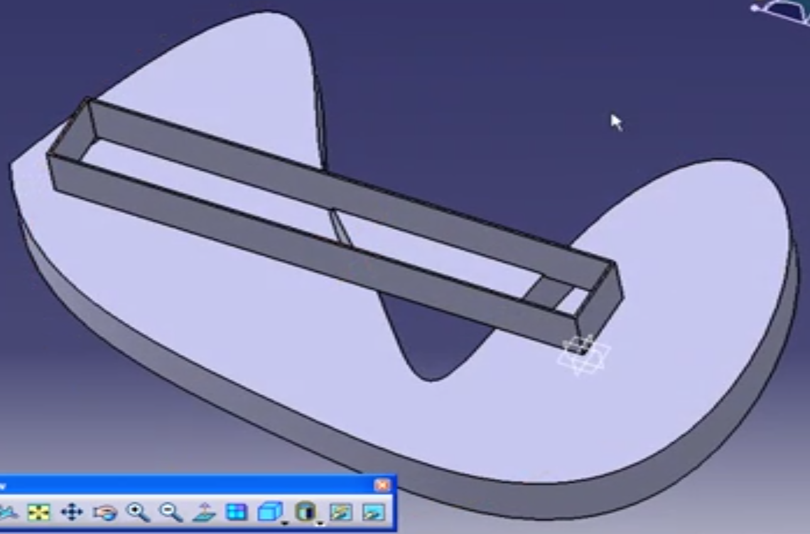

1. **Body Translation**:
   1. Watch tutorial if needed.
   2. Similar to sketch translation
2. **Body Rotation**:
   1. Watch tutorial if needed.
   2. Similar to sketch rotation
3. **Body Symmetry**:
   1. Watch tutorial if needed.
   2. Similar to sketch symmetry
4. **Body Mirror**:
   1. Watch tutorial if needed.
   2. Similar to sketch mirror
5. **Rectangular pattern**
   1. Apply a pattern in a rectangular direction:

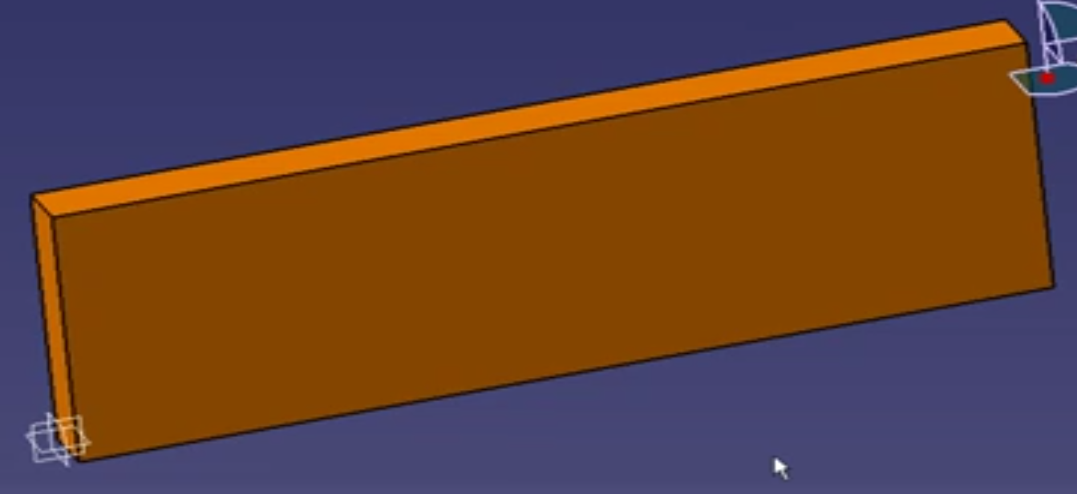 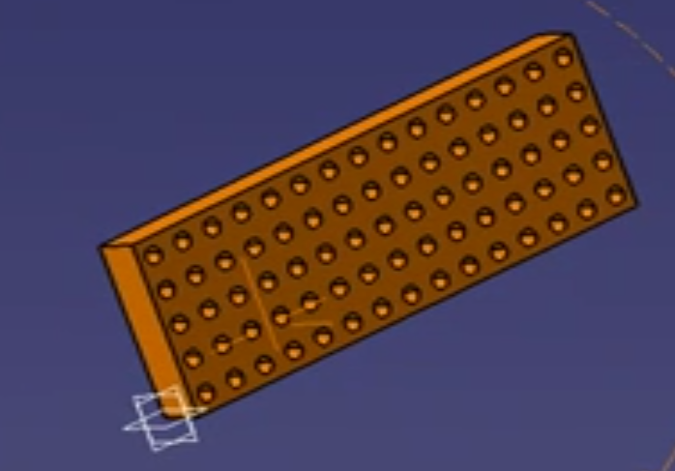

1. **Circular pattern**:
   1. Similar to above, only in a circular direction

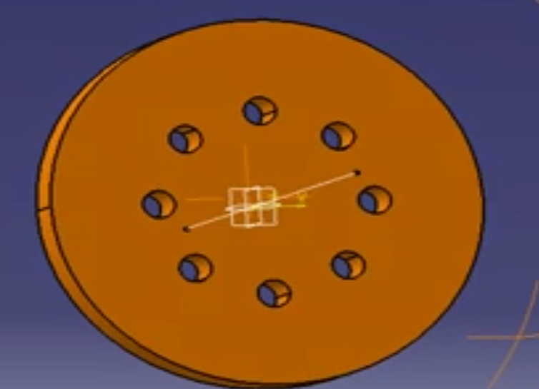

1. **Scale Body**:
   1. Watch tutorial if needed.
   2. Similar to sketch scale
2. **Parallel and perspective view:**
   1. Parallel view is more for modelling. This allows us to zoom to a line.
   2. Perspective view is more for display, to get an idea. Perspective view goes through the model.
3. **Apply Material:**
   1. Watch tutorial if needed
4. **Apply Colour**:
   1. Watch tutorial if needed
5. **Apply Transparency:**
   1. Watch tutorial if needed
6. **Render Style:**
   1. Watch tutorial if needed

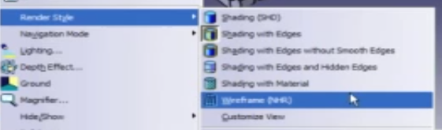

1. **View positions:**
   1. Isometric, front, back, etc
   2. Watch tutorial if needed
2. **Custom View Positions:**
   1. Watch tutorial if needed
3. **Multi View**:
   1. Watch tutorial if needed

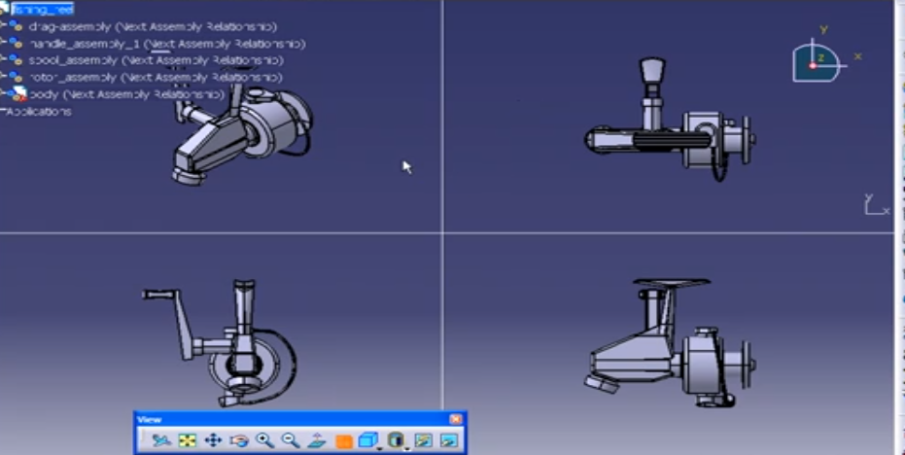

1. **Part Details:**
   1. Watch tutorial if needed
2. **Measure Tools Overview:**

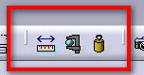

1. **Measure Between**:
   1. Start from the toolbar:

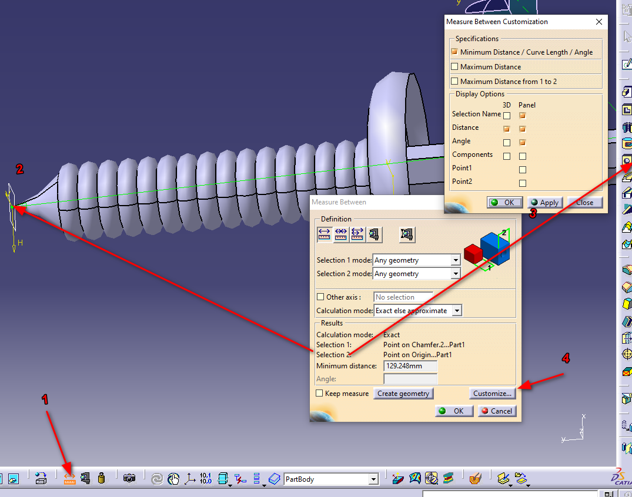

1. Measure Item:
   1. Select a part to measure
   2. Watch tutorial if needed
2. Measure Inertia:

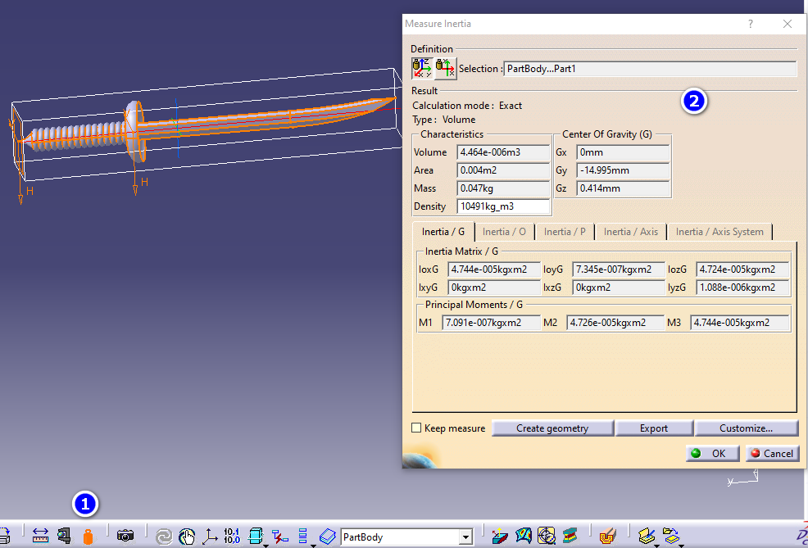

1. **Coating and plating calculations**:
   1. Watch tutorial if needed
2. **Plastic and Forging Calculations**:
   1. Watch tutorial if needed
3. **Search Function**:
   1. You are able to search similar types of components and then perform operations on them (hide/show, delete, apply material, colour, etc).
   2. For example you can search for all planes and hide them.
   3. Watch tutorial if needed
4. **Compass Component Intro**:
   1. You can use the compass to translate or rotate parts or whole assemblies.
5. **Compass Translate Part:**
   1. You can hold your mouse over the red center of the compass this will turn the cursor into a cross.
   2. You will then be able to drag and drop the compass over a face, part or assembly.
   3. This will move the compass to that location.
   4. Then you will be able to use the axes to translate the part in that direction
   5. Either drag and drop the axis or double click on the axis to open a menu with compass manipulation options.
   6. You can select only specific parts to which the translation would apply. Watch the tutorial if needed.

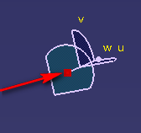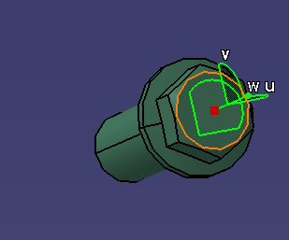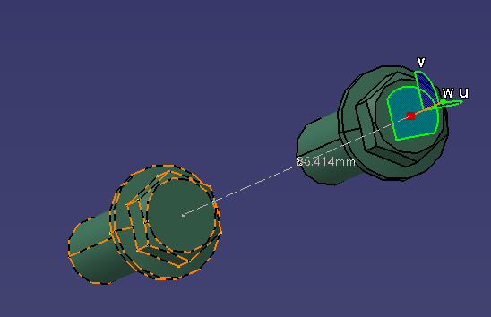

1. **Compass Translate Assembly:**
   1. Similar to above, watch tutorial if needed.
2. **Compass Rotate Part:**
   1. Similar to above, watch tutorial if needed.
3. **Compass Rotate Assembly:**
   1. Similar to above, watch tutorial if needed.
4. **Missing**
5. **Adding Part Bodies:**
   1. This allows us to split a part into different selectable bodies.
   2. We can then apply Boolean Operations to the part bodies.
   3. Watch tutorial if needed.
6. **Boolean Operations Overview**: